Sedum Makinoi ‘Ogon’
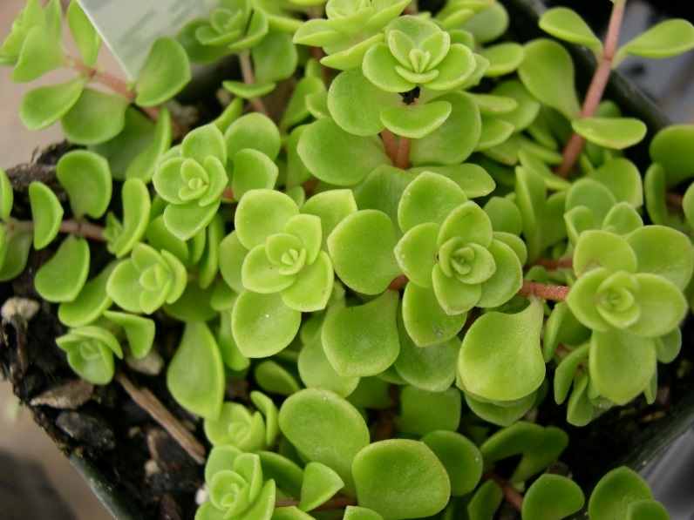
“Stonecrop”
Description / History: ‘Ogon’ is a tiny-leaved spreading ground cover sedum that is noted for its bright gold foliage. It typically forms a dense mat growing to only 2” high and creeping to 12” wide or more. Individual rounded leaves are only 1/4” wide. Best golden leaf color usually occurs with some part afternoon shade. Leaf color gives rise to the sometime used common name of Japanese golden sedum for this plant. Tiny, star-like, yellow-green flowers appear in summer.
Growth Requirements:
- Light: Place in a bright, indirectly lit south, east, or west window.
- Water / Humidity: Water thoroughly when the soil ½ inch below the surface is dry. Discard drainage. Dry air generally does no harm.
- Temperature: 50°-55° F at night, 65°-70° F during day.
- Fertilization: Fertilize lightly with a low-nitrogen fertilizer in spring and summer. Continue fertilizing, though even more lightly, through fall and winter for succulents that grow actively the year round.
- Propagation: Stem cuttings and offsets root easily. Dry the offset or cutting for a few days until a callus forms, then plant in well-drained potting mix and keep barely moist. Many succulents can also be reproduced from leaf cuttings.
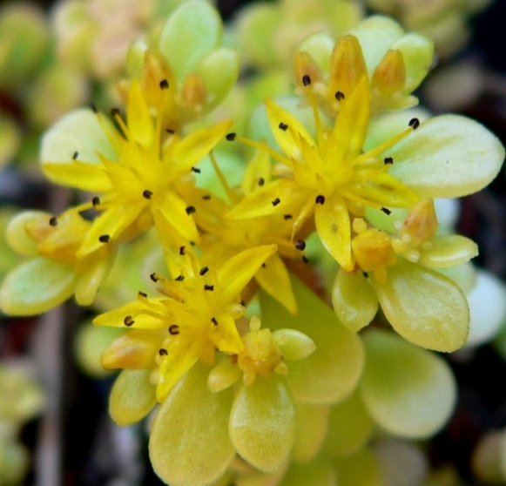
- Grooming / Repotting: Cut off flower stalks as the blooms age. Repot only every 3 or 4 years, when essential. Use a shallow pot and a very porous soil.
- Problems with Plant: Root rot can result from soggy soil caused by poor drainage or excessive watering. Stem or leaf rot may be caused by cool, damp air. Leaves wilt and discolor from too much water, especially in winter. Brown dry spots are caused by underwatering.

